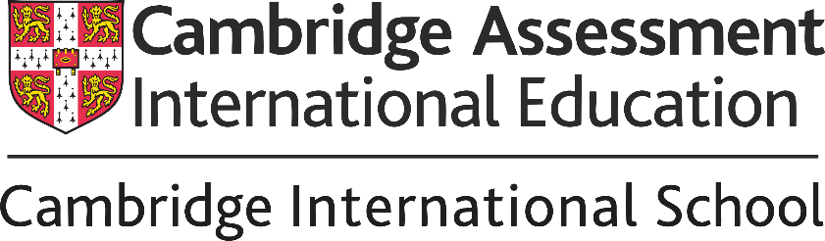

We also offer the globally recognised Cambridge Assessment International Education curriculum from Classes I–VIII, with higher grades being added progressively each year. Through enquiry-based learning and international benchmarks, students develop confidence, creativity, critical thinking, and a global outlook. Here, learners are not just prepared for examinations — they are prepared for the world beyond classrooms.

Why Parents Across the World Choose Cambridge?

- Globally Recognised Qualifications
- International Mindset
- Enquiry-Based Learning
- Personalised Subject Choices
- International Benchmarking
- Future-Ready Skills
- Seamless Learning Pathway (Primary → Lower Secondary → IGCSE → AS & A Levels)
- Holistic Development

Cambridge Lower Secondary Checkpoint Results
At the end of Classes V and VIII, students appear for the internationally benchmarked Cambridge Checkpoint Assessments in English, Mathematics, and Science. These assessments are independently set, administered & evaluated by Cambridge UK, offering parents a transparent and authentic measure of student progress against global standards.
Below is the Checkpoint Result of the last three years showing that every single one of them has scored above the international average in all subjects (Checkpoint scores of 21 to 30 consistently correspond to the Good performance band) at the Cambridge Assessment.

Subject | 2021–22 | 2022–23 | 2023–24
English | 36/50 | 35/50 | 34/50
Mathematics | 47/50 | 42/50 | 44/50
Science | 42/50 | 41/50 | 37/50
*Each learner receives a personalised Statement of Achievement from Cambridge International, highlighting strengths, areas of growth, and readiness for future academic pathways.
Similarly, Cambridge Students year after year have also scored above the national benchmarking in ASSET Exam. ASSSET is a skill-based diagnostic assessment that evaluates students' conceptual understanding and critical thinking in core subjects like English, Mathematics, Science, and Social Studies. Unlike conventional tests, it assesses logical reasoning and practical application rather than rote smemorization.

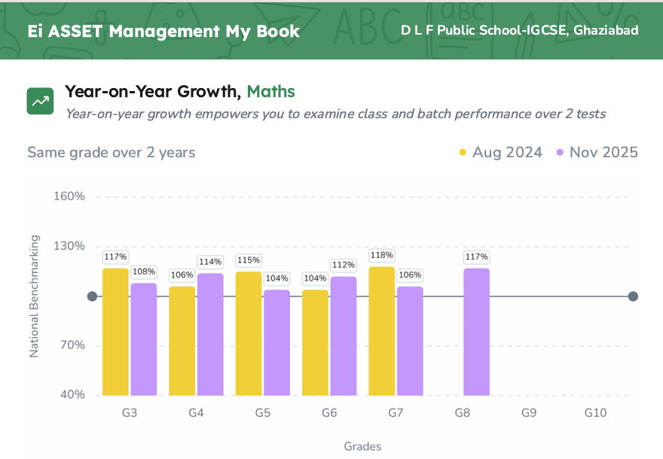
Subjects Offered
Cambridge IGCSE | Class IX Onwards
Languages  - English as a First Language (Compulsory)  - Hindi  - French  - German | Humanities & Social Sciences  - Global Perspectives  - History  - Geography  - Sociology
Sciences  - Physics  - Chemistry  - Biology  Commerce & Technology  - Economics  - Business Studies  - Computer Science | Mathematics  - Mathematics Core  - Mathematics Extended

Our flexible subject combinations allow learners to personalise their academic journey based on their interests, abilities, and future aspirations — whether in engineering, medicine, humanities, business, design, or emerging global careers.

Frequently Asked Questions
You Asked. We Answered.
1. Is Cambridge accepted in India?
Yes. Cambridge IGCSE is recognised by the Association of Indian Universities (AIU) and accepted by CBSE, ISC, State Boards, and universities across India and abroad.
2. Can Cambridge students prepare for JEE or NEET?
Absolutely. Students can pursue JEE, NEET, CUET, UPSC, NDA, and other competitive examinations with the right subject choices and academic planning.
3. What is the Cambridge Checkpoint?
Checkpoint is an internationally benchmarked assessment conducted in Classes V and VIII that evaluates student understanding in English, Mathematics, and Science.
4. How is Cambridge different from traditional boards?
Cambridge focuses on conceptual understanding, application, research, analysis, discussion, and real-world problem-solving rather than rote learning.
5. How many subjects does a student study in IGCSE?
Typically, students opt for 7–9 subjects, including core and elective choices tailored to their interests and future goals.
6. Are Cambridge classrooms more interactive?
Yes. Students actively participate through discussions, presentations, experiments, collaborative projects, and inquiry-driven learning experiences.
7. Can students shift to another board later?
Yes. Students can smoothly transition to CBSE, ISC, State Boards, or continue with Cambridge AS & A Levels.
8. Is Cambridge suitable for students moving abroad?
Absolutely. Cambridge qualifications are internationally portable and recognised in over 160 countries worldwide.
9. Are examinations conducted in school?
Yes. As an authorised Cambridge examination centre, all Cambridge examinations are conducted at our campus under international standards and protocols.
10. What kind of learner does Cambridge develop?
Cambridge nurtures learners who are confident, responsible, reflective, innovative, and engaged — young people prepared not only for examinations, but for life itself.

Added by Ms. Chhavi on June 23
The Cambridge Pathway at DLF Public School
A seamless, progressive academic journey — Class I through A Levels
Stage | Classes | Focus
Cambridge Primary | I – V | Foundations in literacy, numeracy, and inquiry
Cambridge Lower Secondary | VI – VIII | Deepening skills across core disciplines
Cambridge IGCSE* | IX – X | Broad, flexible subject choices with global benchmarking
Cambridge AS & A Levels* | XI – XII | Specialised pathways for university and career readiness
*Higher grades are being added progressively each year.

- Cambridge Primary is taught in more than 2,500 schools in over 120 countries, with over 130,000 entries annually for Cambridge Primary Checkpoint.
- Cambridge Lower Secondary is taught in more than 4,000 schools in nearly 140 countries.
- Cambridge IGCSE is the world's most popular international qualification for 14 to 16-year-olds, offered in over 150 countries and in nearly 6,000 schools.
- Cambridge O Level qualifications are also taught in more than 50 countries.
- Cambridge International AS & A Levels are taken in more than 130 countries, with hundreds of thousands of students entering each year.
- Cambridge qualifications are recognised by over 2,350 universities in 90 countries.
For more information visit: https://www.cambridgeinternational.org/

